
USER INTERFACE -PROJECT

SUBMITTED BY
NAME | T.MANOJ
ROLL NO. | AV.SC.U4CSE2546
YEAR/SEM/SECTION | 1ST YEAR /SEM2/CSE-C
CREDITS | 03

SUBMITTED TO | DR.RAJ KUMAR BATCHU
DESIGNATION | ASST.PROFFESSOR (Sl. Gd.)
DEPARTMENT | SCHOOL OF COMPUTING

AIM:TO GENERATE A CLONE BOOKMYSHOW WEBSITE.

CODE:
<!DOCTYPE html>
<html lang="en">
<head>
<meta charset="UTF-8">
<meta name="viewport" content="width=device-width, initial-scale=1.0">
<title>BookMyShow - Movies, Events & More</title>
<link rel="stylesheet" href="style.css">
</head>
<body>

<!-- NAVBAR -->
<nav class="navbar" id="navbar">
<div class="nav-container">
<div class="nav-logo">
<span class="logo-icon">🎬</span>
<span class="logo-text">BookMyShow</span>
</div>
<div class="nav-search">
<input type="text" id="searchInput" placeholder="Search movies, events, plays..." />
<button class="search-btn" onclick="handleSearch()">🔍</button>
</div>
<ul class="nav-links" id="navLinks">
<li><a href="#movies" class="nav-link active">Movies</a></li>
<li><a href="#events" class="nav-link">Events</a></li>
<li><a href="#about" class="nav-link">About</a></li>
<li><a href="#" class="nav-btn-signin">Sign In</a></li>
</ul>
<div class="hamburger" id="hamburger" onclick="toggleMenu()">
<span></span><span></span><span></span>
</div>
</div>
</nav>

<!-- HERO SECTION -->
<section class="hero" id="home">
<div class="hero-slider" id="heroSlider">

<!-- Slide 1 -->
<div class="hero-slide active">
<img class="hero-bg-img" src="peddi.jpg" alt="PEDDI" />
<div class="hero-overlay"></div>
<div class="hero-content">
<span class="hero-tag">NOW SHOWING</span>
<h1 class="hero-title">PEDDI</h1>
<p class="hero-desc">In a rural village, a determined young man rises through fierce sporting contests, confronting rivalry, pride and the weight of expectation.</p>
<div class="hero-meta">
<span class="rating">⭐ 9.1/10</span>
<span class="genre">Action • COMDEY</span>
<span class="duration">⏱ 2h 56m</span>
</div>
<div class="hero-btns">
<button class="btn-primary" onclick="bookNow('PEDDI')">Book Tickets</button>
<button class="btn-secondary">Watch Trailer</button>
</div>
</div>
<!-- <div class="hero-img-wrap">
<img src="peddi1.jpg" alt="PEDDI" class="hero-poster" />
</div>-->
</div>

<!-- Slide 2 -->
<div class="hero-slide">
<img class="hero-bg-img" src="veerabhadrudu.jpg" alt="VEERABHADRUDU" />
<div class="hero-overlay" style="background: linear-gradient(90deg, rgba(10,40,20,0.92) 40%, rgba(10,40,20,0.3));"></div>
<div class="hero-content">
<span class="hero-tag">TRENDING</span>
<h1 class="hero-title">VEERABHADRUDU</h1>
<p class="hero-desc">A lawyer becomes possessed by a deity and battles injustice affecting marginalized communities..</p>
<div class="hero-meta">
<span class="rating">⭐ 8.4/10</span>
<span class="genre">Adventure • Drama</span>
<span class="duration">⏱ 2h 48m</span>
</div>
<div class="hero-btns">
<button class="btn-primary" onclick="bookNow('VEERABHARUDU')">Book Tickets</button>
<button class="btn-secondary">Watch Trailer</button>
</div>
</div>
<!-- <div class="hero-img-wrap">
<img src="https://images.unsplash.com/photo-1516912481808-3406841bd33c?w=400&q=80" alt="Jungle Poster" class="hero-poster" />
</div>-->
</div>

<!-- Slide 3 -->
<div class="hero-slide">
<img class="hero-bg-img" src="ROCKSTAR.jpg" alt="Concert" />
<div class="hero-overlay" style="background: linear-gradient(90deg, rgba(30,0,80,0.92) 40%, rgba(30,0,80,0.3));"></div>
<div class="hero-content">
<span class="hero-tag">SPECIAL EVENT</span>
<h1 class="hero-title">ANIRUDH</h1>
<p class="hero-desc">Hitting the stage and bringing the house down! The one and only Rockstar Anirudh.When the beat drops, the madness begins! </p>
<div class="hero-meta">
<span class="rating">⭐ 10/10</span>
<span class="genre">Music • Concert</span>
<span class="duration">⏱ 2H 28M</span>
</div>
<div class="hero-btns">
<button class="btn-primary" onclick="bookNow('GODARI GATTUPAINA')">Book Now</button>
<button class="btn-secondary">View Details</button>
</div>
</div>
<!--<div class="hero-img-wrap">
<img src="https://images.unsplash.com/photo-1493225457124-a3eb161ffa5f?w=400&q=80" alt="Concert Poster" class="hero-poster" />
</div>-->
</div>

</div>
<!-- Slider Dots -->
<div class="slider-dots" id="sliderDots">
<span class="dot active" onclick="goToSlide(0)"></span>
<span class="dot" onclick="goToSlide(1)"></span>
<span class="dot" onclick="goToSlide(2)"></span>
</div>
</section>

<!-- CATEGORY TABS -->
<section class="categories">
<div class="container">
<div class="cat-tabs" id="catTabs">
<button class="cat-tab active" onclick="filterCards('all', this)">All</button>
<button class="cat-tab" onclick="filterCards('movie', this)">🎬 Movies</button>
<button class="cat-tab" onclick="filterCards('event', this)">🎉 Events</button>
<button class="cat-tab" onclick="filterCards('music', this)">🎵 Music</button>
<button class="cat-tab" onclick="filterCards('sport', this)">🏏 Sports</button>
</div>
</div>
</section>

<!-- MOVIES / CARDS SECTION -->
<section class="movies-section" id="movies">
<div class="container">
<div class="section-header">
<h2 class="section-title">Recommended For You</h2>
<a href="#" class="see-all">See All &rarr;</a>
</div>
<div class="cards-grid" id="cardsGrid">

<div class="card" data-type="movie">
<div class="card-img">
<img src="peddi.jpg" alt="PEDDI" />
<div class="card-badge">NEW</div>
</div>
<div class="card-body">
<h3 class="card-title">PEDDI</h3>
<p class="card-meta">Action • COMDEY</p>
<div class="card-foot">
<span class="card-rating">⭐ 9.1</span>
<button class="card-btn" onclick="bookNow('PEDDI')">Book</button>
</div>
</div>
</div>

<div class="card" data-type="movie">
<div class="card-img">
<img src="veerabhadrudu.jpg" alt="VEERABHARUDU" />
<div class="card-badge hot">HOT</div>
</div>
<div class="card-body">
<h3 class="card-title">VEERABHARUDU/h3>
<p class="card-meta">FANTASY • Drama</p>
<div class="card-foot">
<span class="card-rating">⭐ 8.4</span>
<button class="card-btn" onclick="bookNow('VEERABHARUDU')">Book</button>
</div>
</div>
</div>

<div class="card" data-type="music">
<div class="card-img">
<img src="ROCKSTAR.jpg" alt="Concert" />
<div class="card-badge event">LIVE</div>
</div>
<div class="card-body">
<h3 class="card-title">ROCKSTAR ANIRUDH</h3>
<p class="card-meta">MUSIC • DANCE</p>
<div class="card-foot">
<span class="card-rating">⭐ 10</span>
<button class="card-btn" onclick="bookNow('ANIRUDH ROCKSTAR')">Book</button>
</div>
</div>
</div>

<div class="card" data-type="movie">
<div class="card-img">
<img src="DRISHYAM1010.jpeg" alt="Space" />
</div>
<div class="card-body">
<h3 class="card-title">DRISHYAM 3</h3>
<p class="card-meta">ACTION • Thriller</p>
<div class="card-foot">
<span class="card-rating">⭐ 9.4</span>
<button class="card-btn" onclick="bookNow('DRISHYAM 3')">Book</button>
</div>
</div>
</div>

<div class="card" data-type="event">
<div class="card-img">
<img src="VARANASI88.jpeg" alt="Comedy" />
<div class="card-badge event">EVENT</div>
</div>
<div class="card-body">
<h3 class="card-title">VARANASI EVENT </h3>
<p class="card-meta">MUSIC • DANCE</p>
<div class="card-foot">
<span class="card-rating">⭐ 8.7</span>
<button class="card-btn" onclick="bookNow('VARANASI EVENT')">Book</button>
</div>
</div>
</div>

<div class="card" data-type="sport">
<div class="card-img">
<img src="https://images.unsplash.com/photo-1540747913346-19e32dc3e97e?w=400&q=80" alt="Cricket" />
<div class="card-badge hot">IPL</div>
</div>
<div class="card-body">
<h3 class="card-title">CSK vs MI Final</h3>
<p class="card-meta">Cricket • IPL 2025</p>
<div class="card-foot">
<span class="card-rating">⭐ 9.9</span>
<button class="card-btn" onclick="bookNow('CSK vs MI Final')">Book</button>
</div>
</div>
</div>

</div>
</div>
</section>

<!-- EVENTS SECTION -->
<section class="events-section" id="events">
<div class="container">
<div class="section-header">
<h2 class="section-title">Upcoming Events</h2>
<a href="#" class="see-all">View All &rarr;</a>
</div>
<div class="events-grid">

<div class="event-card">
<img src="https://images.unsplash.com/photo-1540575467063-178a50c2df87?w=120&q=80" alt="Tech Summit" class="event-thumb" />
<div class="event-date-box">
<span class="ev-day">15</span>
<span class="ev-month">JUN</span>
</div>
<div class="event-info">
<h4>Tech Summit 2025</h4>
<p>🏛 Chennai Trade Centre</p>
<p>💰 From ₹999</p>
</div>
<button class="ev-btn" onclick="bookNow('Tech Summit 2025')">Register</button>
</div>

<div class="event-card">
<img src="https://images.unsplash.com/photo-1470229722913-7c0e2dbbafd3?w=120&q=80" alt="Sunburn" class="event-thumb" />
<div class="event-date-box" style="background:#ee0979;">
<span class="ev-day">22</span>
<span class="ev-month">JUN</span>
</div>
<div class="event-info">
<h4>Sunburn Music Fest</h4>
<p>🏟 DY Patil Stadium</p>
<p>💰 From ₹1499</p>
</div>
<button class="ev-btn" onclick="bookNow('Sunburn Music Fest')">Register</button>
</div>

<div class="event-card">
<img src="https://images.unsplash.com/photo-1555939594-58d7cb561ad1?w=120&q=80" alt="Food Fest" class="event-thumb" />
<div class="event-date-box" style="background:#56ab2f;">
<span class="ev-day">05</span>
<span class="ev-month">JUL</span>
</div>
<div class="event-info">
<h4>Food & Wine Festival</h4>
<p>🌆 Bangalore Palace Grounds</p>
<p>💰 From ₹500</p>
</div>
<button class="ev-btn" onclick="bookNow('Food & Wine Festival')">Register</button>
</div>

</div>
</div>
</section>

<!-- ABOUT SECTION -->
<section class="about-section" id="about">
<div class="container">
<div class="about-wrap">
<div class="about-text">
<span class="about-tag">Who We Are</span>
<h2>India's #1 Entertainment Ticketing Platform</h2>
<p>ShowBook makes it super easy to discover and book tickets for movies, events, concerts, sports and more. With 100+ cities covered and over 5 crore happy customers, we bring entertainment closer to you.</p>
<div class="stats-row">
<div class="stat-box"><h3>5Cr+</h3><p>Happy Users</p></div>
<div class="stat-box"><h3>100+</h3><p>Cities</p></div>
<div class="stat-box"><h3>50K+</h3><p>Events</p></div>
</div>
</div>
<div class="about-img-side">
<img src="https://images.unsplash.com/photo-1489599849927-2ee91cede3ba?w=500&q=80" alt="Cinema" class="about-img" />
</div>
</div>
</div>
</section>

<!-- FOOTER -->
<footer class="footer">
<div class="container">
<div class="footer-grid">
<div class="footer-col">
<h4>🎬 BookMyShow</h4>
<p>Your go-to platform for booking tickets for movies, events, concerts and more.</p>
</div>
<div class="footer-col">
<h4>Movies</h4>
<ul>
<li><a href="#">Now Showing</a></li>
<li><a href="#">Upcoming</a></li>
<li><a href="#">Top Rated</a></li>
</ul>
</div>
<div class="footer-col">
<h4>Events</h4>
<ul>
<li><a href="#">Concerts</a></li>
<li><a href="#">Sports</a></li>
<li><a href="#">Workshops</a></li>
</ul>
</div>
<div class="footer-col">
<h4>Help</h4>
<ul>
<li><a href="#">Contact Us</a></li>
<li><a href="#">FAQs</a></li>
<li><a href="#">Refund Policy</a></li>
</ul>
</div>
</div>
<div class="footer-bottom">
<p>&copy; 2025 BookMyShow. Made with ❤️ for entertainment lovers.</p>
</div>
</div>
</footer>

<!-- BOOKING MODAL -->
<div class="modal-overlay" id="modalOverlay" onclick="closeModal()">
<div class="modal-box" onclick="event.stopPropagation()">
<button class="modal-close" onclick="closeModal()">✕</button>
<h3 id="modalTitle">Book Tickets</h3>
<p id="modalDesc">Select your seats and proceed.</p>
<div class="seat-picker">
<p>Select Seats:</p>
<div class="seats" id="seatGrid"></div>
</div>
<div class="modal-foot">
<p>Selected: <span id="selectedCount">0</span> seat(s) | Total: ₹<span id="totalPrice">0</span></p>
<button class="btn-primary" onclick="confirmBooking()">Confirm Booking</button>
</div>
</div>
</div>

<!-- Toast -->
<div class="toast" id="toast"></div>

<script src="script.js"></script>
</body>
</html>

CSS CODE:
/* ShowBook - style.css | CSS Box Model, Flexbox, Grid, Transitions, Animations */
:root {
--red: #e03131; --red-dark: #b91c1c;
--dark: #1a1a2e; --dark2: #16213e; --card-bg: #1e2a3a;
--text: #f1f5f9; --muted: #94a3b8; --accent: #f4c430;
--border: rgba(255,255,255,0.08); --radius: 12px; --t: 0.3s ease;
}
* { margin: 0; padding: 0; box-sizing: border-box; }
html { scroll-behavior: smooth; }
body { font-family: 'Segoe UI', Tahoma, sans-serif; background: var(--dark); color: var(--text); line-height: 1.6; }
a { text-decoration: none; color: inherit; }
ul { list-style: none; }
.container { max-width: 1200px; margin: 0 auto; padding: 0 20px; }

/* NAVBAR */
.navbar {
position: fixed; top: 0; width: 100%; z-index: 1000;
background: rgba(26,26,46,0.95); backdrop-filter: blur(10px);
border-bottom: 1px solid var(--border); transition: background var(--t);
}
.navbar.scrolled { background: rgba(22,33,62,0.99); box-shadow: 0 2px 20px rgba(0,0,0,0.4); }
.nav-container {
max-width: 1200px; margin: 0 auto; padding: 0 20px;
display: flex; align-items: center; height: 64px; gap: 20px;
}
.nav-logo { display: flex; align-items: center; gap: 8px; font-size: 1.4rem; font-weight: 700; color: var(--red); flex-shrink: 0; }
.logo-icon { font-size: 1.5rem; }
.nav-search {
flex: 1; display: flex; align-items: center;
background: rgba(255,255,255,0.07); border: 1px solid var(--border);
border-radius: 30px; padding: 6px 14px; max-width: 420px; transition: border-color var(--t);
}
.nav-search:focus-within { border-color: var(--red); }
.nav-search input { flex: 1; background: transparent; border: none; outline: none; color: var(--text); font-size: 0.9rem; }
.nav-search input::placeholder { color: var(--muted); }
.search-btn { background: none; border: none; cursor: pointer; font-size: 1rem; }
.nav-links { display: flex; align-items: center; gap: 24px; }
.nav-link { color: var(--muted); font-size: 0.95rem; transition: color var(--t); position: relative; }
.nav-link::after { content: ''; position: absolute; bottom: -4px; left: 0; width: 0; height: 2px; background: var(--red); transition: width var(--t); }
.nav-link:hover, .nav-link.active { color: var(--text); }
.nav-link:hover::after, .nav-link.active::after { width: 100%; }
.nav-btn-signin {
background: var(--red); color: white; padding: 8px 20px; border-radius: 25px;
font-size: 0.9rem; font-weight: 600; transition: background var(--t), transform var(--t); white-space: nowrap;
}
.nav-btn-signin:hover { background: var(--red-dark); transform: translateY(-1px); }
.hamburger { display: none; flex-direction: column; gap: 5px; cursor: pointer; margin-left: auto; }
.hamburger span { display: block; width: 25px; height: 2px; background: var(--text); border-radius: 2px; transition: transform var(--t); }

/* HERO */
.hero { margin-top: 64px; position: relative; overflow: hidden; height: 520px; }
.hero-slider { width: 100%; height: 100%; position: relative; }
.hero-slide {
position: absolute; inset: 0; display: flex; align-items: center; padding: 0 60px;
opacity: 0; transform: translateX(40px); transition: opacity 0.6s ease, transform 0.6s ease; pointer-events: none;
}
.hero-slide.active { opacity: 1; transform: translateX(0); pointer-events: all; }
.hero-content { flex: 1; max-width: 560px; }
.hero-tag {
display: inline-block; background: var(--red); color: white; font-size: 0.75rem;
font-weight: 700; letter-spacing: 2px; padding: 5px 14px; border-radius: 20px;
margin-bottom: 16px; animation: fadeDown 0.5s ease 0.2s both;
}
@keyframes fadeDown { from { opacity: 0; transform: translateY(-10px); } to { opacity: 1; transform: translateY(0); } }
.hero-title { font-size: 2.8rem; font-weight: 800; line-height: 1.1; margin-bottom: 14px; text-shadow: 0 2px 20px rgba(0,0,0,0.5); }
.hero-desc { color: rgba(255,255,255,0.8); font-size: 1rem; margin-bottom: 18px; max-width: 420px; }
.hero-meta { display: flex; gap: 16px; margin-bottom: 28px; flex-wrap: wrap; }
.hero-meta span { font-size: 0.88rem; background: rgba(255,255,255,0.12); padding: 4px 12px; border-radius: 20px; }
.hero-btns { display: flex; gap: 14px; flex-wrap: wrap; }
.btn-primary {
background: var(--red); color: white; border: none; padding: 12px 28px;
border-radius: 30px; font-size: 0.95rem; font-weight: 600; cursor: pointer;
transition: background var(--t), transform var(--t), box-shadow var(--t);
}
.btn-primary:hover { background: var(--red-dark); transform: translateY(-2px); box-shadow: 0 6px 20px rgba(224,49,49,0.4); }
.btn-secondary {
background: rgba(255,255,255,0.12); color: white; border: 1px solid rgba(255,255,255,0.3);
padding: 12px 28px; border-radius: 30px; font-size: 0.95rem; cursor: pointer;
transition: background var(--t), transform var(--t);
}
.btn-secondary:hover { background: rgba(255,255,255,0.22); transform: translateY(-2px); }
.hero-img-wrap { flex-shrink: 0; margin-left: 40px; }
.hero-card-placeholder {
width: 200px; height: 280px; border-radius: 16px; display: flex; align-items: center;
justify-content: center; font-size: 5rem; box-shadow: 0 20px 60px rgba(0,0,0,0.5);
animation: floatUp 3s ease-in-out infinite alternate;
}
@keyframes floatUp { from { transform: translateY(0px); } to { transform: translateY(-12px); } }
.slider-dots { position: absolute; bottom: 20px; left: 50%; transform: translateX(-50%); display: flex; gap: 10px; }
.dot { width: 10px; height: 10px; border-radius: 50%; background: rgba(255,255,255,0.35); cursor: pointer; transition: background var(--t), transform var(--t); }
.dot.active { background: var(--red); transform: scale(1.3); }

/* CATEGORIES */
.categories { padding: 24px 0 10px; background: var(--dark2); }
.cat-tabs { display: flex; gap: 10px; overflow-x: auto; padding-bottom: 4px; }
.cat-tab {
background: var(--card-bg); color: var(--muted); border: 1px solid var(--border);
padding: 9px 22px; border-radius: 25px; font-size: 0.9rem; cursor: pointer; white-space: nowrap;
transition: background var(--t), color var(--t), border-color var(--t);
}
.cat-tab:hover, .cat-tab.active { background: var(--red); color: white; border-color: var(--red); }

/* MOVIES SECTION */
.movies-section { padding: 50px 0; background: var(--dark2); }
.section-header { display: flex; justify-content: space-between; align-items: center; margin-bottom: 28px; }
.section-title { font-size: 1.5rem; font-weight: 700; }
.see-all { color: var(--red); font-size: 0.9rem; font-weight: 600; transition: color var(--t); }
.see-all:hover { color: var(--accent); }
.cards-grid { display: grid; grid-template-columns: repeat(auto-fill, minmax(190px, 1fr)); gap: 22px; }
.card {
background: var(--card-bg); border-radius: var(--radius); overflow: hidden;
border: 1px solid var(--border); transition: transform var(--t), box-shadow var(--t); cursor: pointer;
}
.card:hover { transform: translateY(-6px); box-shadow: 0 16px 40px rgba(0,0,0,0.5); }
.card-img { height: 220px; display: flex; align-items: center; justify-content: center; position: relative; font-size: 4rem; }
.card-emoji { font-size: 4rem; filter: drop-shadow(0 4px 10px rgba(0,0,0,0.4)); }
.card-badge { position: absolute; top: 10px; left: 10px; background: var(--red); color: white; font-size: 0.7rem; font-weight: 700; padding: 3px 10px; border-radius: 10px; letter-spacing: 1px; }
.card-badge.hot { background: #f97316; }
.card-badge.event { background: #7c3aed; }
.card-body { padding: 14px; }
.card-title { font-size: 0.98rem; font-weight: 700; margin-bottom: 4px; white-space: nowrap; overflow: hidden; text-overflow: ellipsis; }
.card-meta { font-size: 0.8rem; color: var(--muted); margin-bottom: 12px; }
.card-foot { display: flex; justify-content: space-between; align-items: center; }
.card-rating { font-size: 0.85rem; color: var(--accent); }
.card-btn { background: var(--red); color: white; border: none; padding: 6px 16px; border-radius: 20px; font-size: 0.8rem; font-weight: 600; cursor: pointer; transition: background var(--t), transform var(--t); }
.card-btn:hover { background: var(--red-dark); transform: scale(1.05); }
.card.hidden { display: none; }

/* EVENTS SECTION */
.events-section { padding: 50px 0; background: var(--dark); }
.events-grid { display: flex; flex-direction: column; gap: 16px; }
.event-card {
background: var(--card-bg); border: 1px solid var(--border); border-radius: var(--radius);
display: flex; align-items: center; gap: 20px; padding: 18px 20px;
transition: transform var(--t), box-shadow var(--t);
}
.event-card:hover { transform: translateX(6px); box-shadow: 0 6px 30px rgba(0,0,0,0.3); }
.event-date-box { background: var(--red); border-radius: 10px; min-width: 56px; height: 56px; display: flex; flex-direction: column; align-items: center; justify-content: center; flex-shrink: 0; }
.ev-day { font-size: 1.3rem; font-weight: 800; line-height: 1; }
.ev-month { font-size: 0.7rem; font-weight: 600; letter-spacing: 1px; }
.event-info { flex: 1; }
.event-info h4 { font-size: 1rem; font-weight: 700; margin-bottom: 6px; }
.event-info p { font-size: 0.85rem; color: var(--muted); }
.ev-btn { background: transparent; border: 1px solid var(--red); color: var(--red); padding: 8px 20px; border-radius: 20px; font-size: 0.85rem; font-weight: 600; cursor: pointer; transition: background var(--t), color var(--t); flex-shrink: 0; }
.ev-btn:hover { background: var(--red); color: white; }

/* ABOUT */
.about-section { padding: 60px 0; background: linear-gradient(135deg, #0f0c29, #302b63, #24243e); }
.about-wrap { display: flex; align-items: center; gap: 60px; }
.about-text { flex: 1; }
.about-tag { display: inline-block; background: rgba(224,49,49,0.15); color: var(--red); border: 1px solid var(--red); font-size: 0.8rem; font-weight: 600; letter-spacing: 2px; padding: 5px 14px; border-radius: 20px; margin-bottom: 16px; text-transform: uppercase; }
.about-text h2 { font-size: 2rem; font-weight: 800; margin-bottom: 16px; line-height: 1.2; }
.about-text p { color: rgba(255,255,255,0.75); font-size: 0.95rem; margin-bottom: 30px; max-width: 460px; }
.stats-row { display: flex; gap: 30px; flex-wrap: wrap; }
.stat-box { text-align: center; }
.stat-box h3 { font-size: 2rem; font-weight: 800; color: var(--accent); }
.stat-box p { font-size: 0.85rem; color: var(--muted); margin-bottom: 0; }
.about-img-side { flex-shrink: 0; }
.about-blob { width: 200px; height: 200px; background: rgba(255,255,255,0.05); border-radius: 50%; display: flex; align-items: center; justify-content: center; font-size: 6rem; border: 2px solid rgba(255,255,255,0.1); animation: pulse 2s ease-in-out infinite alternate; }
@keyframes pulse { from { transform: scale(1); box-shadow: 0 0 0 rgba(224,49,49,0.3); } to { transform: scale(1.06); box-shadow: 0 0 40px rgba(224,49,49,0.3); } }

/* FOOTER */
.footer { background: #0f0f1a; padding: 50px 0 20px; border-top: 1px solid var(--border); }
.footer-grid { display: grid; grid-template-columns: 2fr 1fr 1fr 1fr; gap: 40px; margin-bottom: 40px; }
.footer-col h4 { font-size: 1rem; font-weight: 700; margin-bottom: 14px; }
.footer-col p { color: var(--muted); font-size: 0.88rem; line-height: 1.7; }
.footer-col ul li { margin-bottom: 8px; }
.footer-col ul li a { color: var(--muted); font-size: 0.88rem; transition: color var(--t); }
.footer-col ul li a:hover { color: var(--red); }
.footer-bottom { border-top: 1px solid var(--border); padding-top: 20px; text-align: center; color: var(--muted); font-size: 0.85rem; }

/* MODAL */
.modal-overlay { position: fixed; inset: 0; background: rgba(0,0,0,0.7); display: flex; align-items: center; justify-content: center; z-index: 2000; opacity: 0; pointer-events: none; transition: opacity var(--t); }
.modal-overlay.open { opacity: 1; pointer-events: all; }
.modal-box { background: var(--card-bg); border: 1px solid var(--border); border-radius: 16px; padding: 30px; width: 90%; max-width: 460px; position: relative; transform: translateY(20px); transition: transform var(--t); }
.modal-overlay.open .modal-box { transform: translateY(0); }
.modal-close { position: absolute; top: 14px; right: 16px; background: none; border: none; color: var(--muted); font-size: 1.1rem; cursor: pointer; transition: color var(--t); }
.modal-close:hover { color: var(--red); }
.modal-box h3 { font-size: 1.3rem; margin-bottom: 8px; }
.modal-box p { color: var(--muted); font-size: 0.9rem; margin-bottom: 20px; }
.seat-picker p { font-size: 0.9rem; color: var(--muted); margin-bottom: 10px; }
.seats { display: grid; grid-template-columns: repeat(8, 1fr); gap: 8px; margin-bottom: 20px; }
.seat { width: 100%; aspect-ratio: 1; background: rgba(255,255,255,0.08); border: 1px solid rgba(255,255,255,0.12); border-radius: 5px; cursor: pointer; transition: background var(--t), transform var(--t); font-size: 0.65rem; display: flex; align-items: center; justify-content: center; color: var(--muted); }
.seat:hover { background: rgba(224,49,49,0.3); }
.seat.selected { background: var(--red); color: white; border-color: var(--red); transform: scale(1.1); }
.seat.booked { background: rgba(255,255,255,0.04); color: rgba(255,255,255,0.15); cursor: not-allowed; border-color: transparent; }
.modal-foot { display: flex; justify-content: space-between; align-items: center; flex-wrap: wrap; gap: 12px; }
.modal-foot p { margin: 0; font-size: 0.9rem; color: var(--text); }

/* TOAST */
.toast { position: fixed; bottom: 30px; right: 30px; background: #22c55e; color: white; padding: 12px 22px; border-radius: 10px; font-size: 0.9rem; font-weight: 600; z-index: 3000; transform: translateY(60px); opacity: 0; transition: transform 0.4s ease, opacity 0.4s ease; }
.toast.show { transform: translateY(0); opacity: 1; }

/* RESPONSIVE */
@media (max-width: 900px) {
.footer-grid { grid-template-columns: 1fr 1fr; }
.about-wrap { flex-direction: column; text-align: center; }
.about-text p { margin: 0 auto 30px; }
.stats-row { justify-content: center; }
.hero-img-wrap { display: none; }
.hero-slide { padding: 0 30px; }
.hero-title { font-size: 2rem; }
}
@media (max-width: 650px) {
.nav-links { display: none; position: absolute; top: 64px; left: 0; width: 100%; background: var(--dark2); flex-direction: column; align-items: flex-start; padding: 16px 20px; gap: 16px; border-bottom: 1px solid var(--border); }
.nav-links.open { display: flex; }
.hamburger { display: flex; }
.nav-search { max-width: 200px; }
.hero { height: auto; min-height: 380px; }
.hero-slide { padding: 40px 20px; }
.hero-title { font-size: 1.6rem; }
.cards-grid { grid-template-columns: repeat(2, 1fr); gap: 14px; }
.footer-grid { grid-template-columns: 1fr; gap: 24px; }
.modal-box { padding: 20px; }
}

JAVASCRIPT:

window.onscroll = function () {
var navbar = document.getElementById("navbar");
if (window.scrollY > 50) {
navbar.classList.add("scrolled");
} else {
navbar.classList.remove("scrolled");
}
};

// --- MOBILE HAMBURGER MENU ---
function toggleMenu() {
var navLinks = document.getElementById("navLinks");
navLinks.classList.toggle("open");
}

// Close menu when a nav link is clicked
var navLinks = document.getElementsByClassName("nav-link");
for (var i = 0; i < navLinks.length; i++) {
navLinks[i].addEventListener("click", function () {
document.getElementById("navLinks").classList.remove("open");
});
}

// --- HERO SLIDER ---
var currentSlide = 0;
var slides = document.getElementsByClassName("hero-slide");
var dots = document.getElementsByClassName("dot");
var sliderInterval;

// Show a specific slide
function goToSlide(index) {
// Remove active from current
slides[currentSlide].classList.remove("active");
dots[currentSlide].classList.remove("active");

// Set new index
currentSlide = index;

// Add active to new
slides[currentSlide].classList.add("active");
dots[currentSlide].classList.add("active");
}

// Auto-advance slider every 4 seconds
function startSlider() {
sliderInterval = setInterval(function () {
var next = (currentSlide + 1) % slides.length;
goToSlide(next);
}, 4000);
}

// Restart timer when user manually picks a slide
var originalGoTo = goToSlide;
goToSlide = function (index) {
clearInterval(sliderInterval);
originalGoTo(index);
startSlider();
};

startSlider();

// --- CATEGORY FILTER ---
function filterCards(type, clickedBtn) {
// Update active tab button
var tabs = document.getElementsByClassName("cat-tab");
for (var i = 0; i < tabs.length; i++) {
tabs[i].classList.remove("active");
}
clickedBtn.classList.add("active");

// Show/hide cards based on data-type
var cards = document.getElementsByClassName("card");
for (var j = 0; j < cards.length; j++) {
var cardType = cards[j].getAttribute("data-type");
if (type === "all" || cardType === type) {
cards[j].classList.remove("hidden");
} else {
cards[j].classList.add("hidden");
}
}
}

// --- SEARCH ---
function handleSearch() {
var query = document.getElementById("searchInput").value.trim().toLowerCase();

if (query === "") {
showToast("Please enter something to search!");
return;
}

// Simple search: highlight cards that match
var cards = document.getElementsByClassName("card");
var found = 0;

for (var i = 0; i < cards.length; i++) {
var title = cards[i].getElementsByClassName("card-title")[0].textContent.toLowerCase();
if (title.indexOf(query) !== -1) {
cards[i].classList.remove("hidden");
found++;
} else {
cards[i].classList.add("hidden");
}
}

if (found === 0) {
showToast("No results found for '" + query + "'");
// Show all after 2 seconds
setTimeout(function () {
for (var j = 0; j < cards.length; j++) {
cards[j].classList.remove("hidden");
}
}, 2000);
} else {
showToast("Found " + found + " result(s) for '" + query + "'");
}
}

// Search on Enter key
document.getElementById("searchInput").addEventListener("keydown", function (e) {
if (e.key === "Enter") {
handleSearch();
}
});

// --- BOOKING MODAL ---
var currentBooking = "";
var selectedSeats = [];
var ticketPrice = 250;

// Pre-booked seat numbers (just for realism)
var bookedSeats = [3, 7, 11, 15, 20, 25];

function bookNow(showName) {
currentBooking = showName;
selectedSeats = [];

// Update modal title
document.getElementById("modalTitle").textContent = showName;
document.getElementById("modalDesc").textContent = "Pick your seats below. ₹250 per seat.";
document.getElementById("selectedCount").textContent = "0";
document.getElementById("totalPrice").textContent = "0";

// Build seat grid (24 seats)
var seatGrid = document.getElementById("seatGrid");
seatGrid.innerHTML = "";

for (var i = 1; i <= 24; i++) {
var seat = document.createElement("div");
seat.className = "seat";
seat.textContent = i;
seat.setAttribute("data-seat", i);

if (bookedSeats.indexOf(i) !== -1) {
seat.classList.add("booked");
} else {
// Use closure to capture i
seat.addEventListener("click", (function (seatNum, el) {
return function () {
toggleSeat(seatNum, el);
};
})(i, seat));
}

seatGrid.appendChild(seat);
}

// Open modal
document.getElementById("modalOverlay").classList.add("open");
}

function toggleSeat(seatNum, el) {
var idx = selectedSeats.indexOf(seatNum);

if (idx === -1) {
// Select it
selectedSeats.push(seatNum);
el.classList.add("selected");
} else {
// Deselect it
selectedSeats.splice(idx, 1);
el.classList.remove("selected");
}

// Update count and price
document.getElementById("selectedCount").textContent = selectedSeats.length;
document.getElementById("totalPrice").textContent = selectedSeats.length * ticketPrice;
}

function closeModal() {
document.getElementById("modalOverlay").classList.remove("open");
}

function confirmBooking() {
if (selectedSeats.length === 0) {
showToast("Please select at least one seat!");
return;
}

var total = selectedSeats.length * ticketPrice;
closeModal();
showToast("🎉 Booked " + selectedSeats.length + " seat(s) for " + currentBooking + "! Total: ₹" + total);

// Add booked seats to booked list (so they stay taken)
for (var i = 0; i < selectedSeats.length; i++) {
bookedSeats.push(selectedSeats[i]);
}
}

// --- TOAST NOTIFICATION ---
function showToast(message) {
var toast = document.getElementById("toast");
toast.textContent = message;
toast.classList.add("show");

// Auto-hide after 3 seconds
setTimeout(function () {
toast.classList.remove("show");
}, 3000);
}

// --- SMOOTH ACTIVE LINK ON SCROLL ---
// Updates navbar link highlight as user scrolls sections
window.addEventListener("scroll", function () {
var sections = ["home", "movies", "events", "about"];
var links = document.getElementsByClassName("nav-link");
var scrollPos = window.scrollY + 100;

for (var s = 0; s < sections.length; s++) {
var el = document.getElementById(sections[s]);
if (!el) continue;
if (scrollPos >= el.offsetTop && scrollPos < el.offsetTop + el.offsetHeight) {
for (var l = 0; l < links.length; l++) {
links[l].classList.remove("active");
}
// Match link by href
for (var l2 = 0; l2 < links.length; l2++) {
if (links[l2].getAttribute("href") === "#" + sections[s]) {
links[l2].classList.add("active");
}
}
}
}
});

// --- CARD HOVER SOUND EFFECT (subtle) ---
// Just a small DOM trick: adds a short scale animation on card hover
var allCards = document.getElementsByClassName("card");
for (var c = 0; c < allCards.length; c++) {
allCards[c].addEventListener("mouseenter", function () {
this.style.borderColor = "rgba(224, 49, 49, 0.3)";
});
allCards[c].addEventListener("mouseleave", function () {
this.style.borderColor = "";
});
}

OUTPUT:

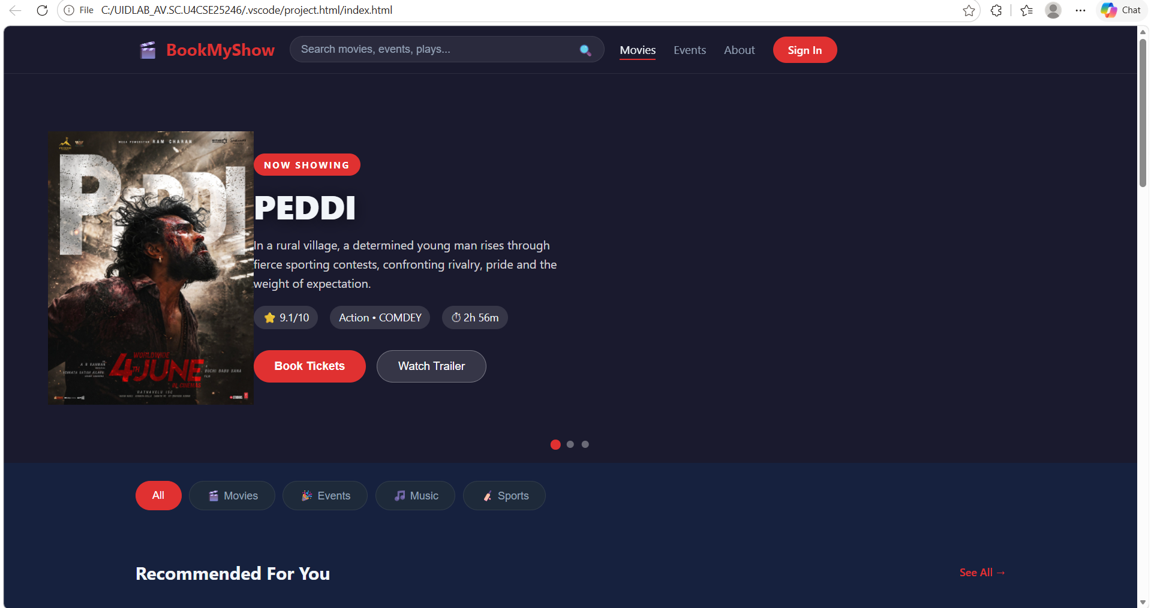

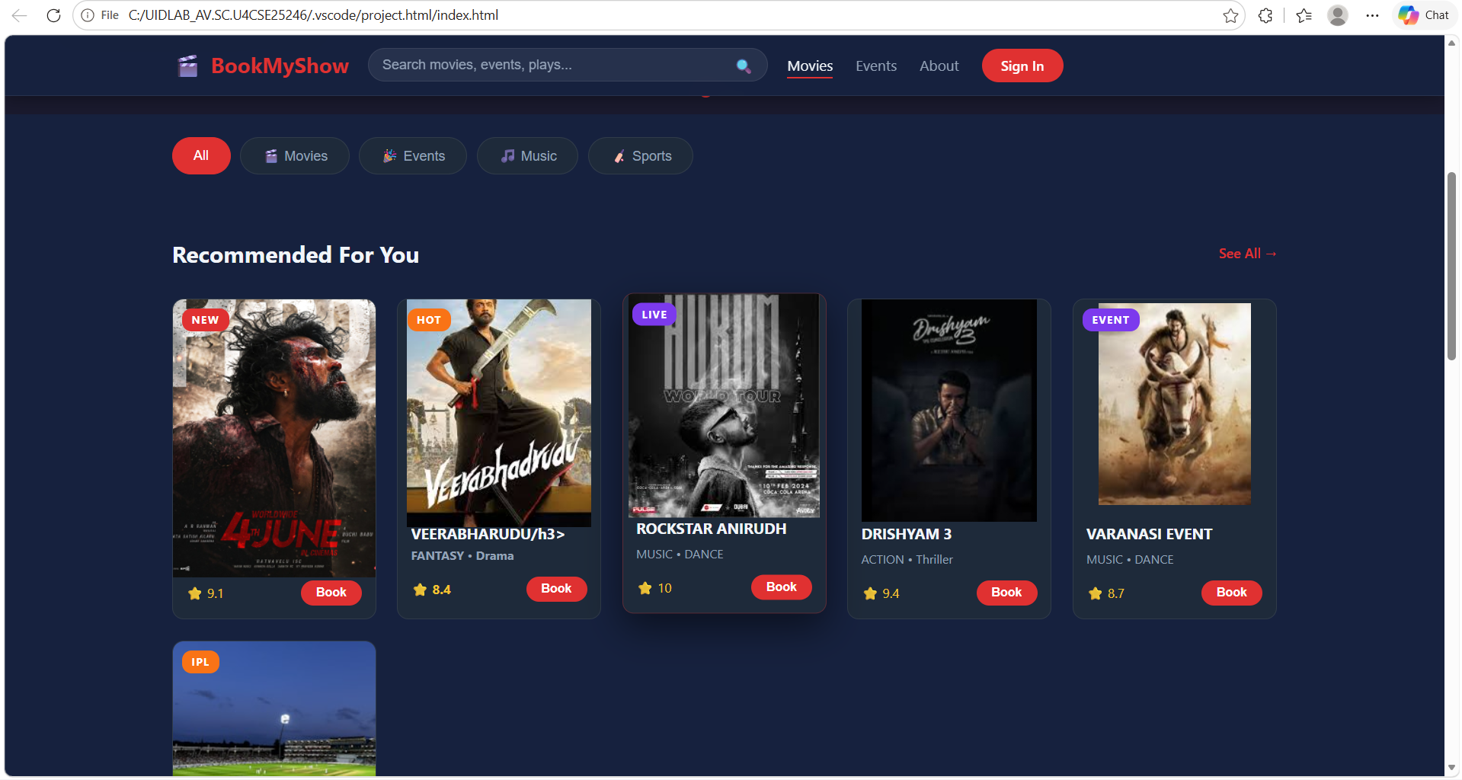

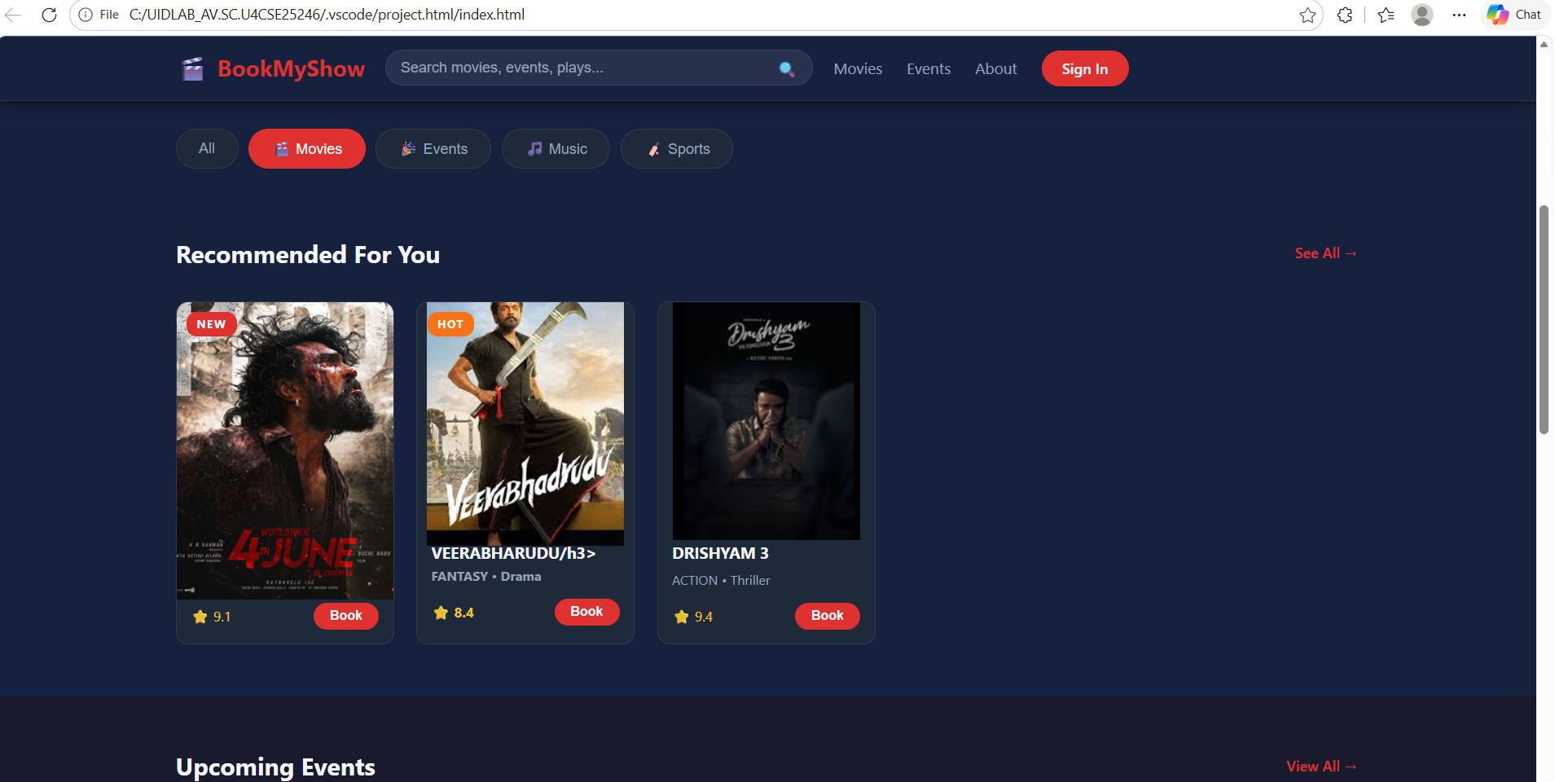

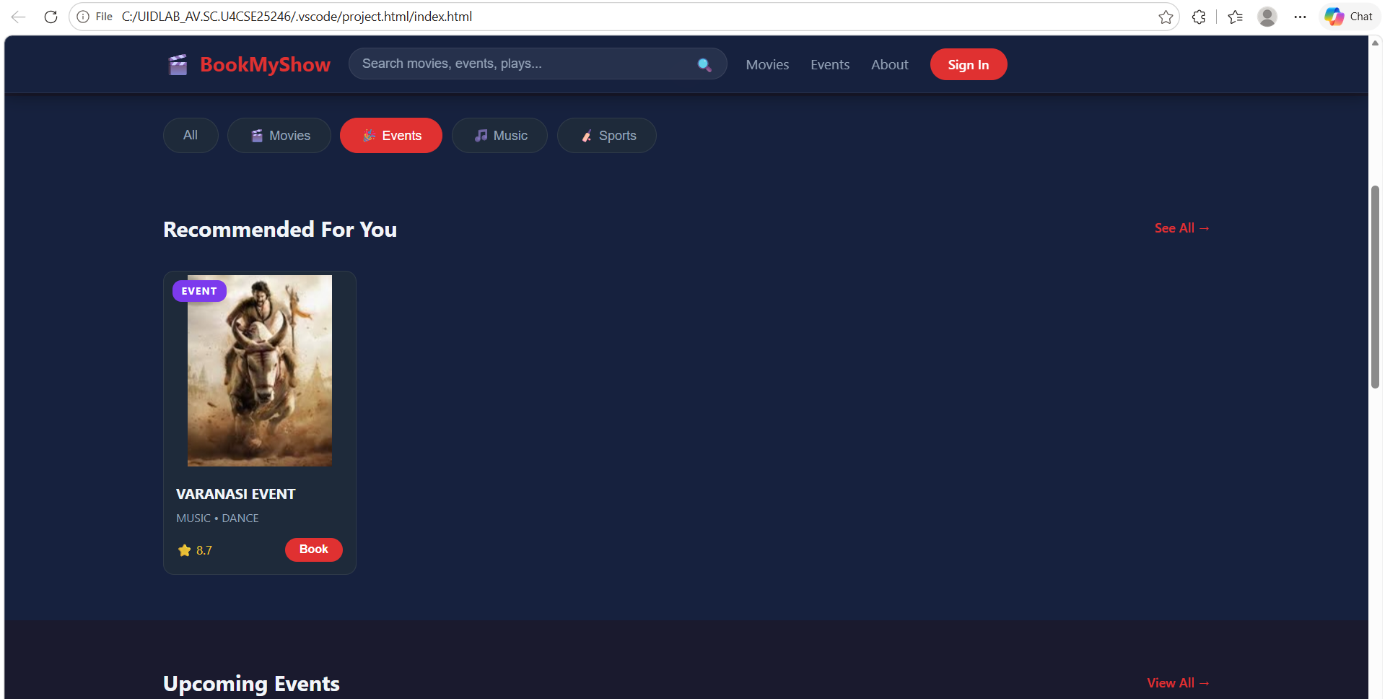

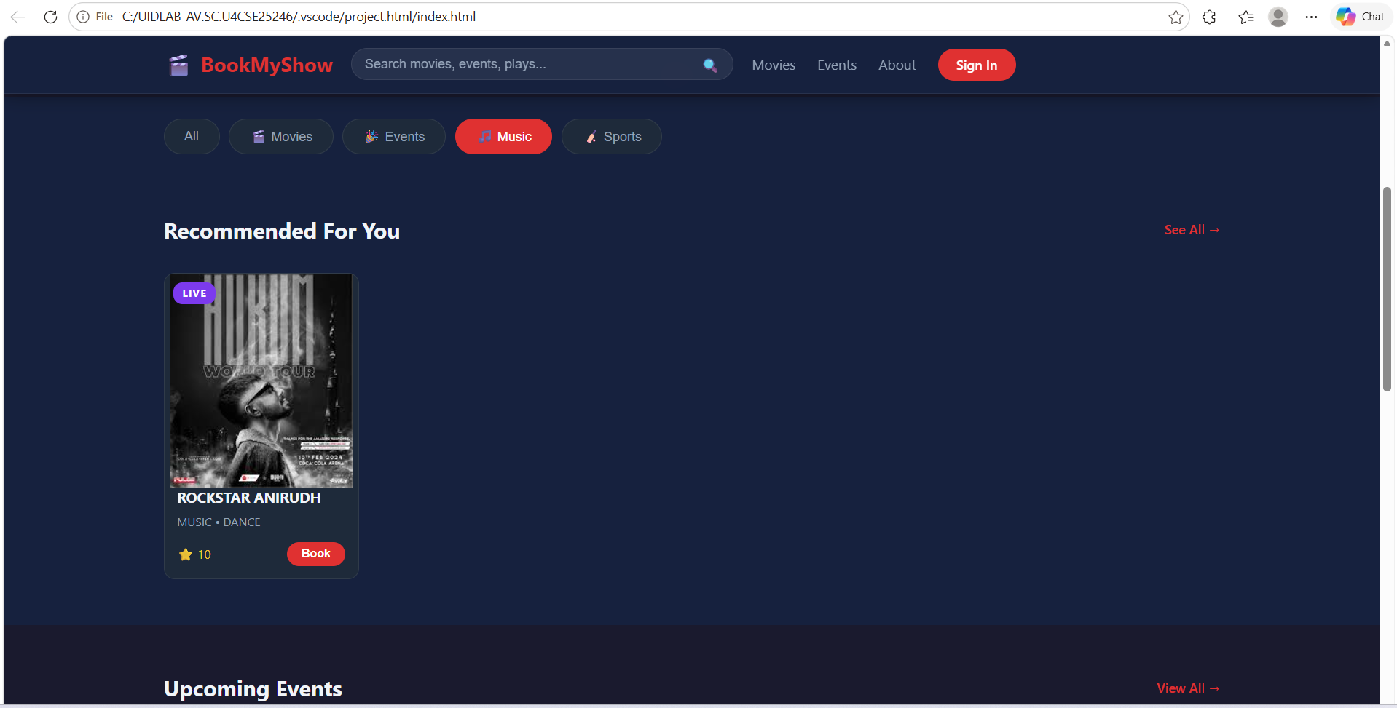

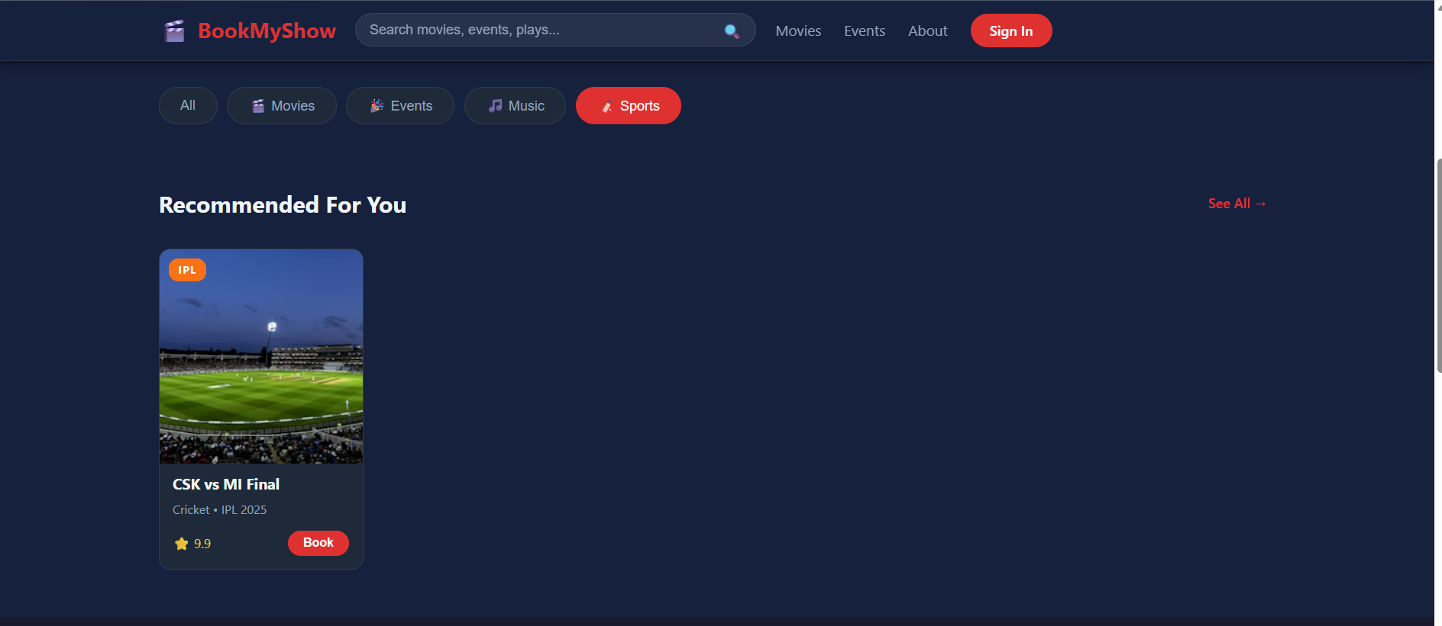

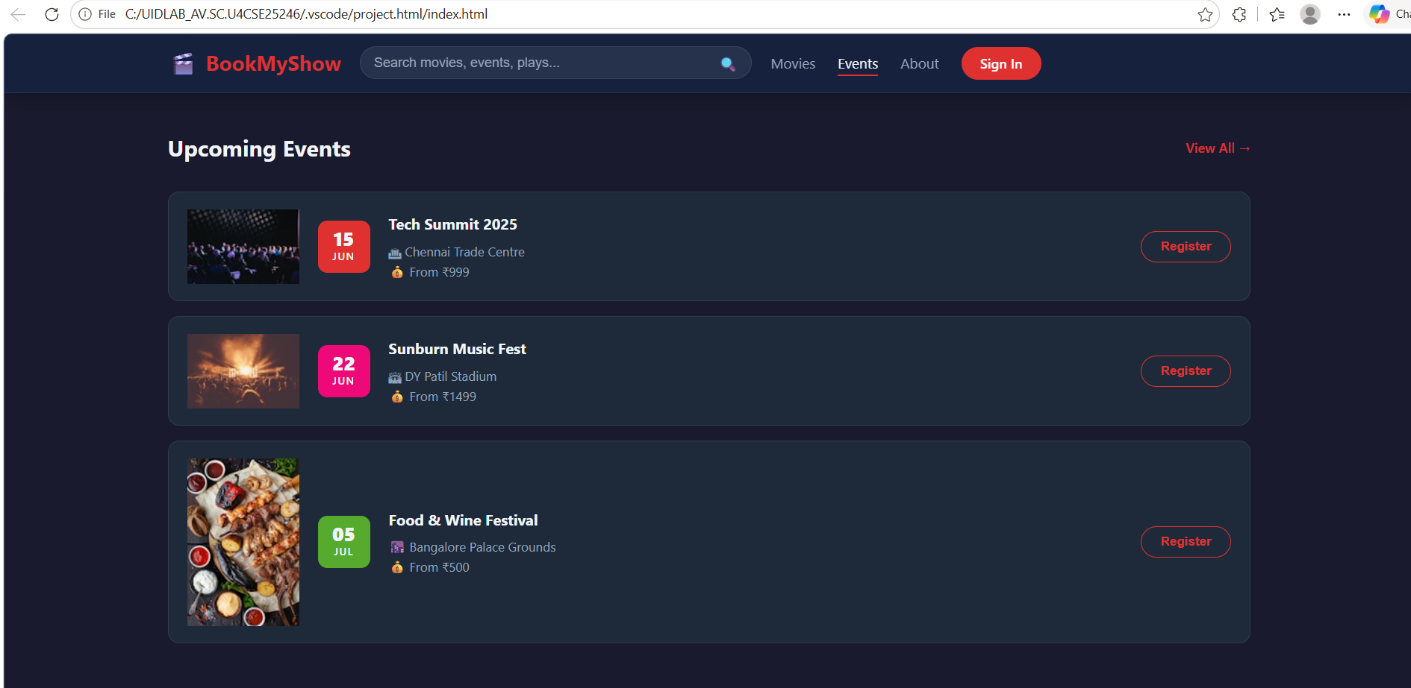

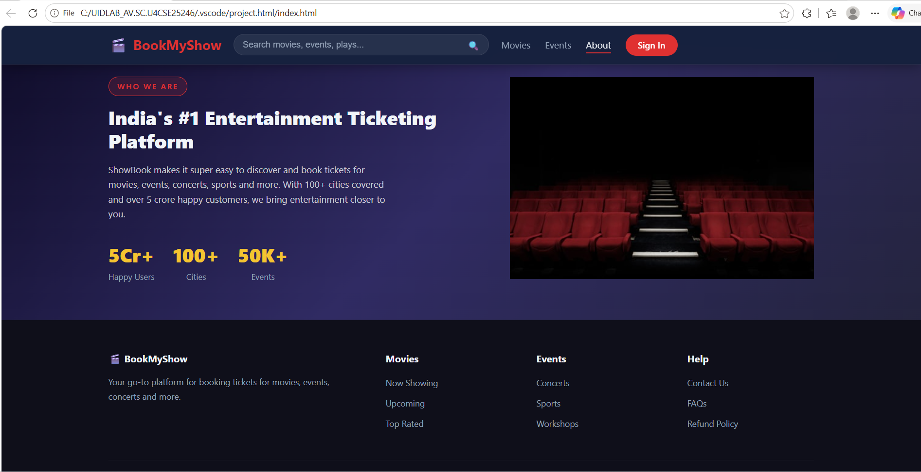

EXPLANATION:

Your BookMyShow project is a modern entertainment ticket booking web application built using HTML, CSS, and JavaScript. It allows users to explore movies, events, music shows, and sports in a visually rich interface.

The navigation bar is fixed and includes a search box, links, and a mobile-friendly hamburger menu.
The hero section contains an auto-sliding banner showcasing featured content with smooth transitions and interactive dots.

Category tabs enable filtering of cards dynamically using JavaScript, improving user experience.

Each movie or event is displayed as a card with images, ratings, and a booking button. The search function lets users find shows by title and highlights matching results.

A booking modal system allows seat selection, price calculation, and confirmation with real-time updates.

CSS Grid and Flexbox are used for layout structure, while animations and transitions enhance interactivity and visual appeal.

The website is fully responsive, adapting to mobile and desktop screens. JavaScript handles DOM manipulation, event listeners, slider control, filtering, and toast notifications.

Overall, this project demonstrates strong frontend development skills, combining UI design, interactivity, and user-friendly booking functionality similar to real-world platforms like online movie ticketing systems.

